**VAISHALI BOKADIYA**

**DEVOPS CODING ASSESSMENT**

**QUESTION 1**

**Question:**

**Create Azure Devops Environment and configuring Azure Devops Git Repository, configure on your local git to implement this upload few test files on same.**

Azure DevOps is a Microsoft product that provides project management, version control and many other services.

It has the following components:

1. Boards
2. Repos
3. Pipelines
4. Test plans
5. Artifacts

Repos is a version control tools that you can use to manage your code.

Open Microsoft Azure and go to Azure DevOps Organisations

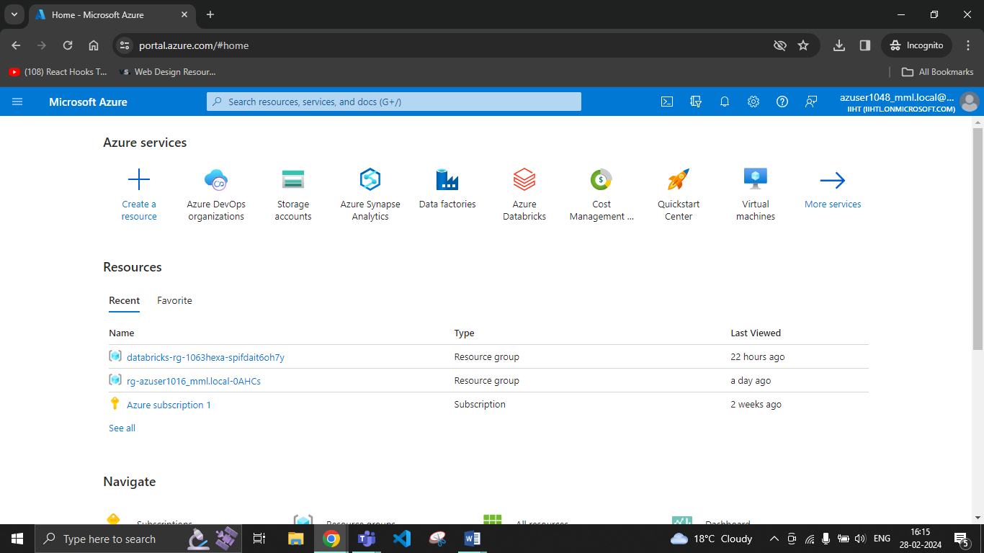

Click on My Azure DevOps Organisations

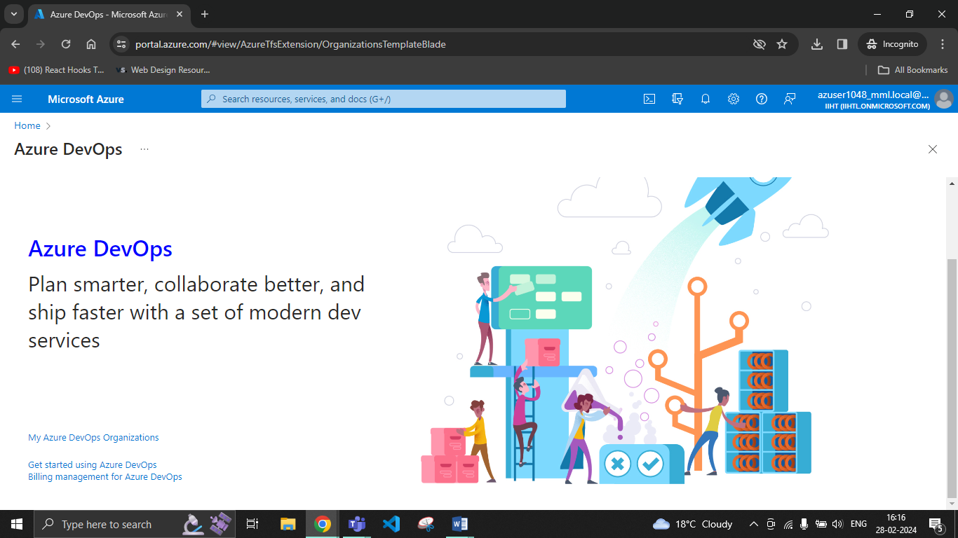

Click on Create new organisation

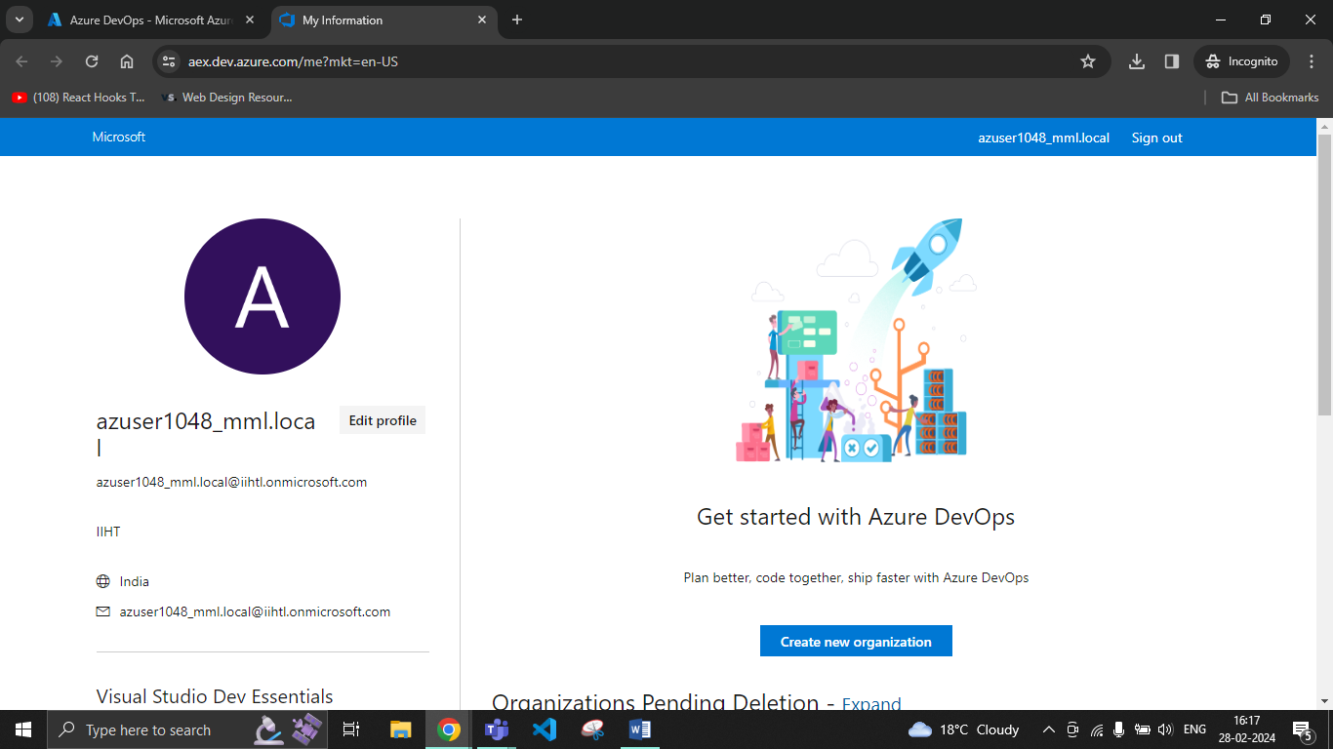

Click on Continue

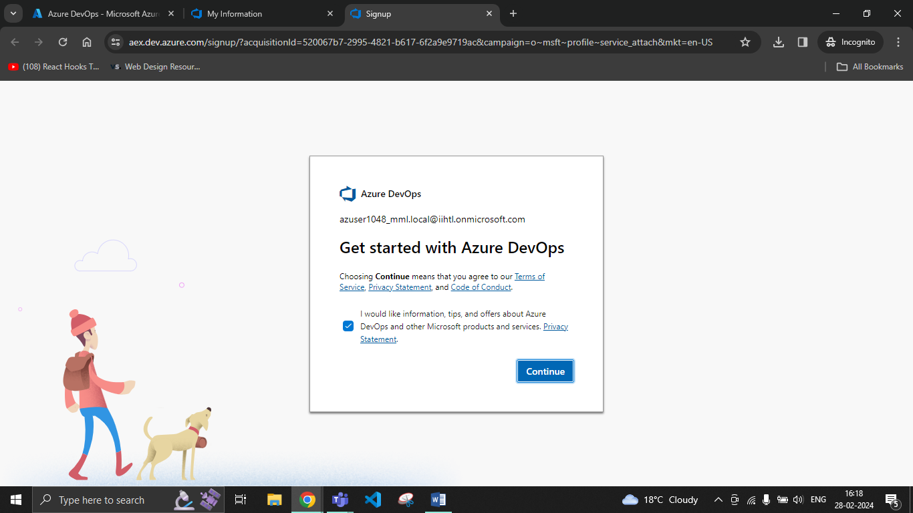

Click on Continue

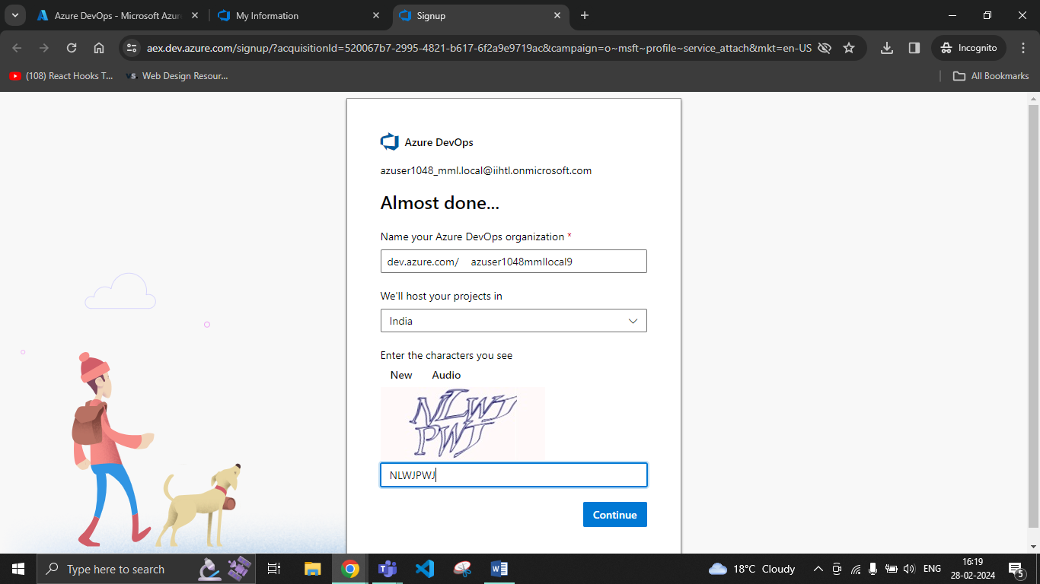

Create a new Project

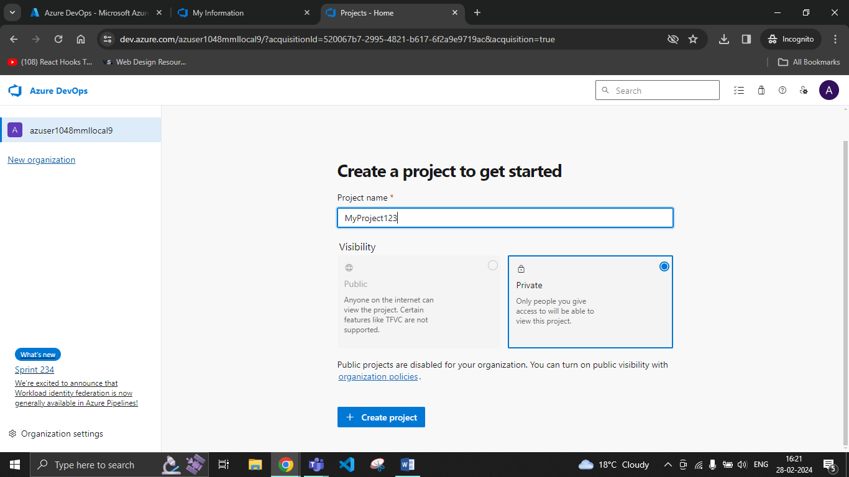

Project created successfully, now go to Repos

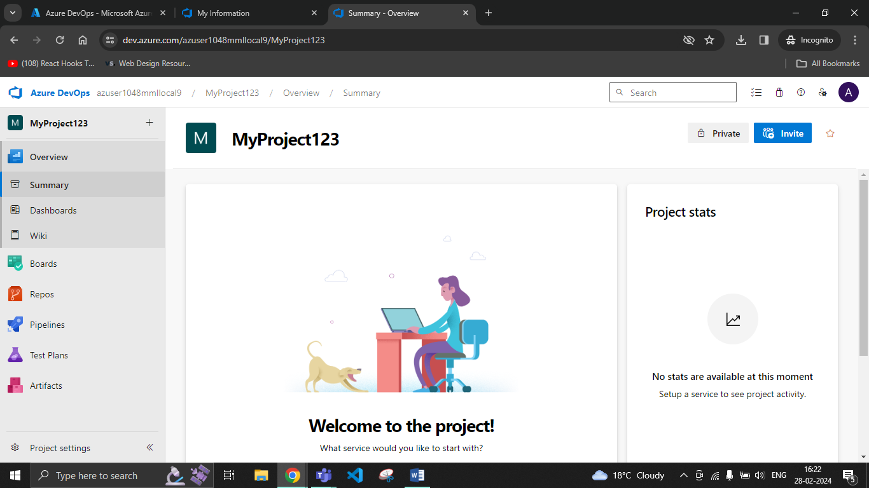

**Committing and Pushing:**

Open Git Bash, make a new folder and initialize git repository in it

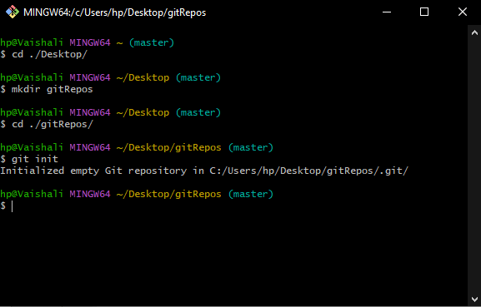

Create some new files in the directory

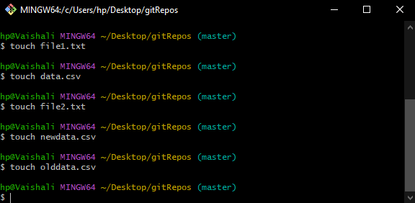

Commit these files in the git

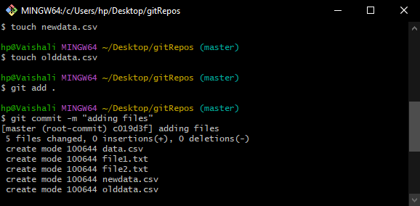

From Repos copy the push commands

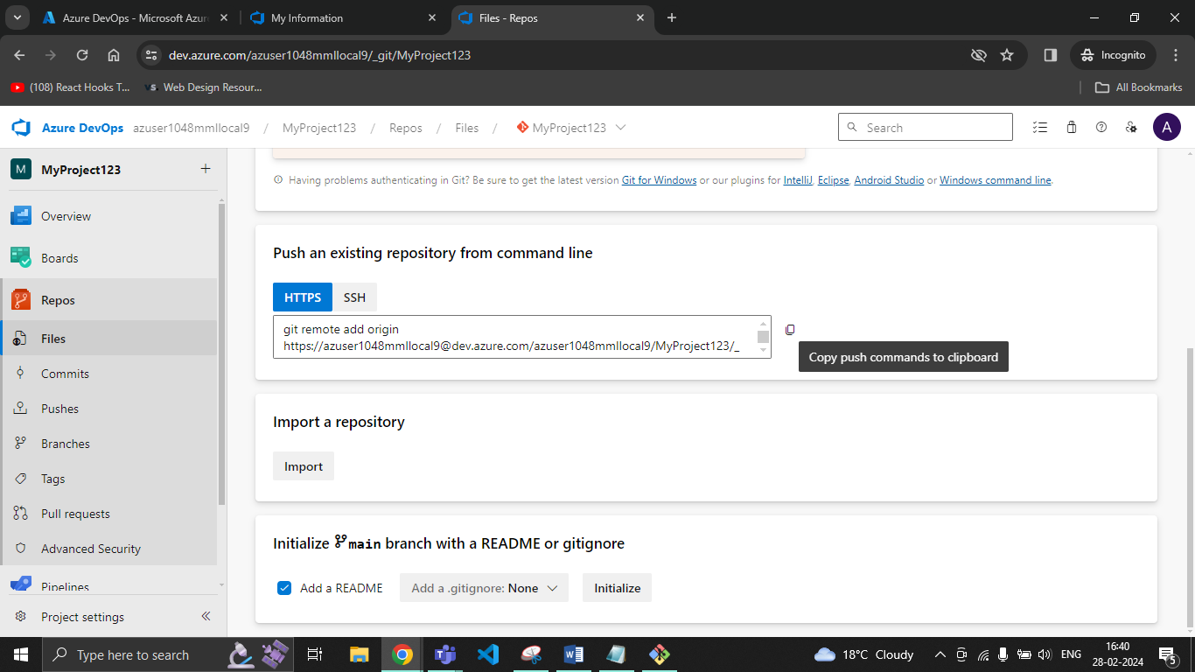

Push all the files to the repo by pasting the push command

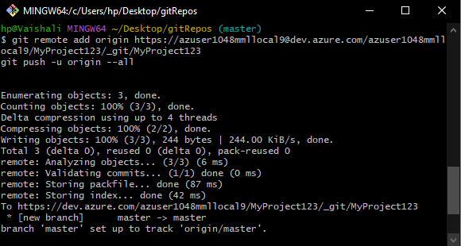

You can see the commits in your repos

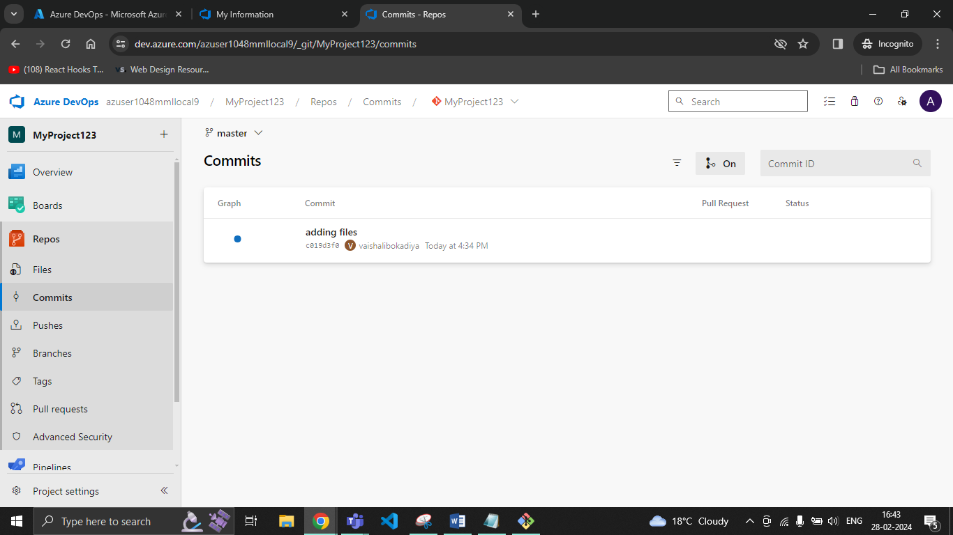

Repos Pushes:

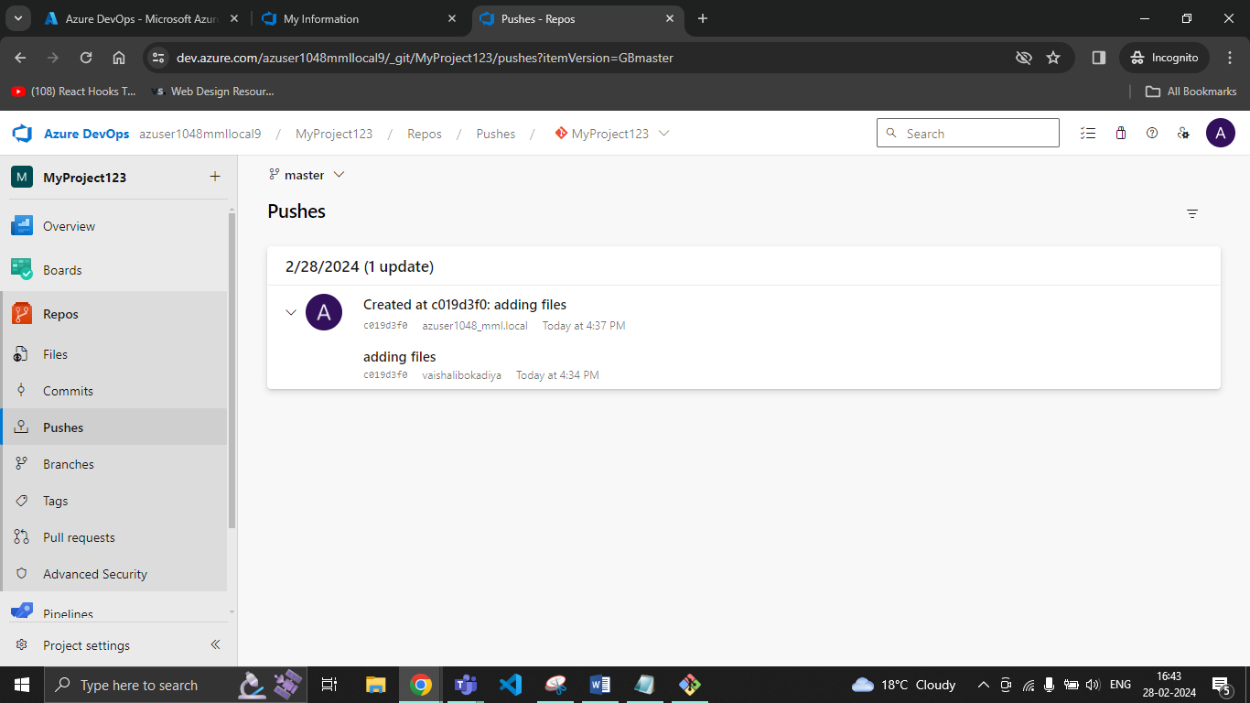

Add some more files and commit and push them

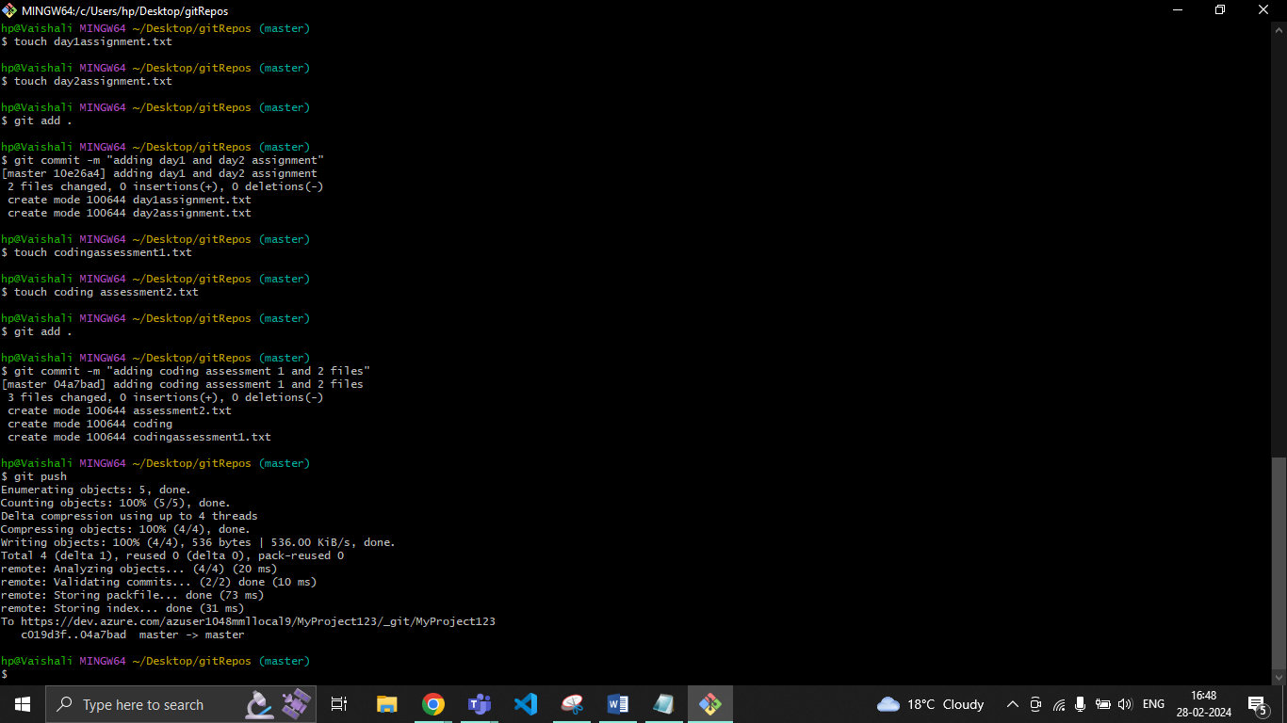

Repos Commits: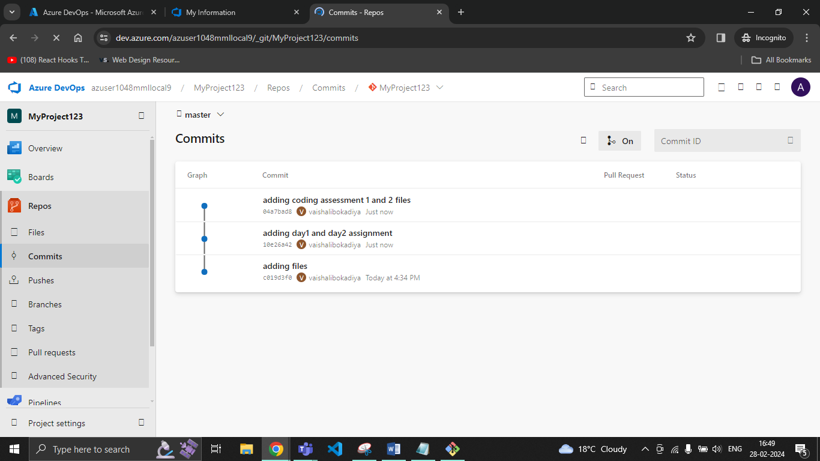

Repos Pushes:

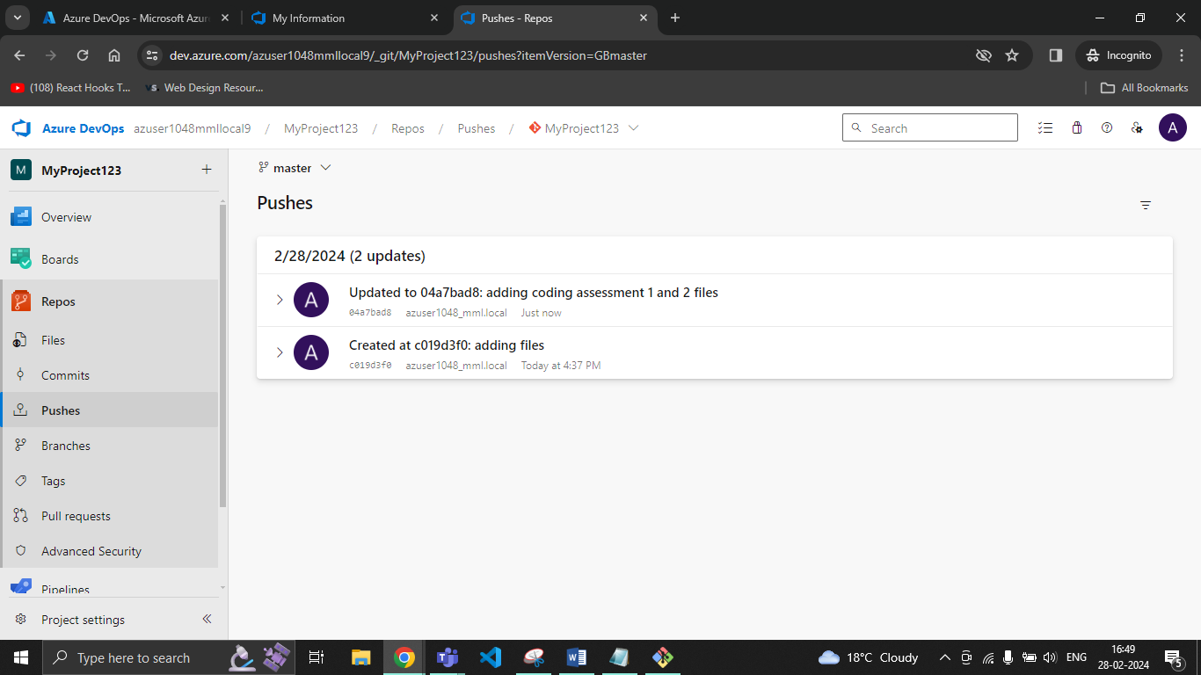

**Cloning:**

Open Git bash and create a new folder and initialize git repository in it

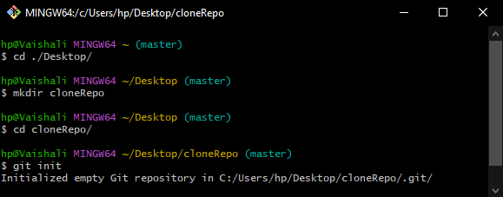

Go to Repos and click on Clone

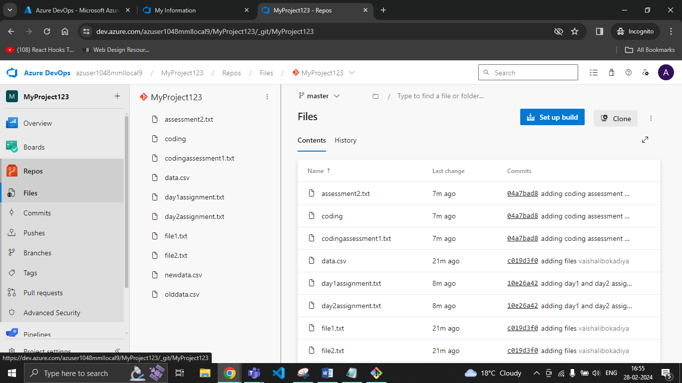

Copy the clone URL

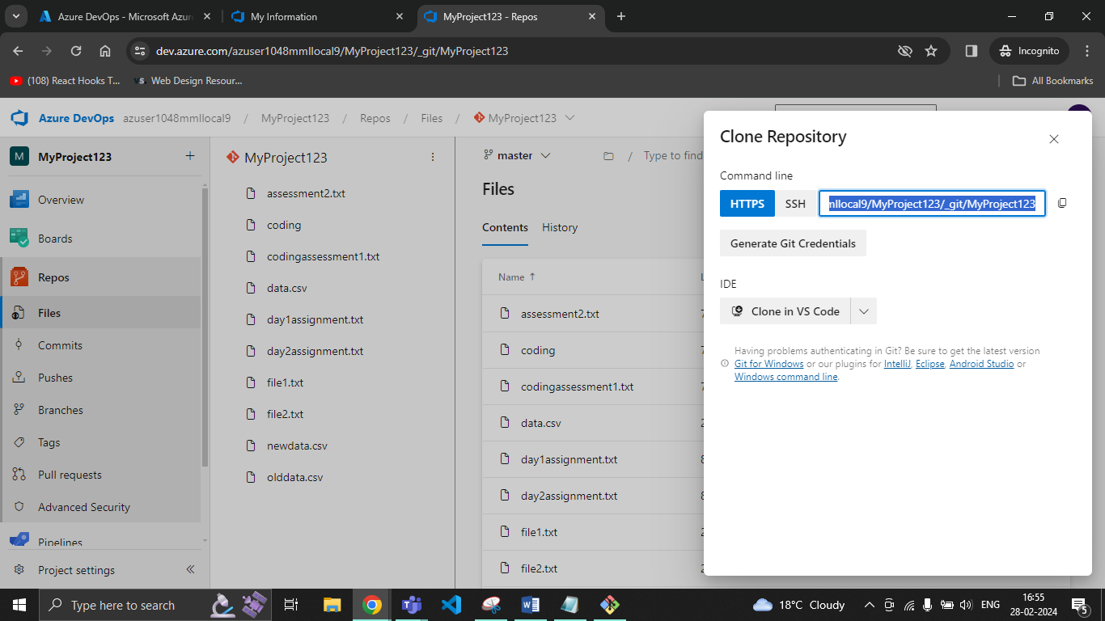

Write “git clone” and add the copied URL in the Git bash

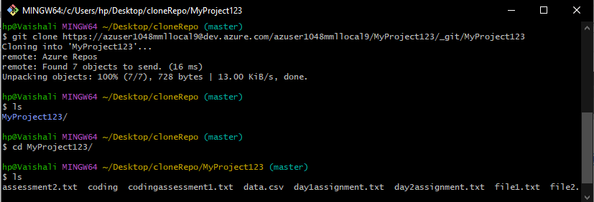

**Pulling:**

